Dear Sir,

Let me take this opportunity to thank you for the Enquiry you have given us. With reference to the discussion we had with you, we are pleased to place the following before you.

- Introduction
- Technical Proposal-after Site Visit.
- Commercial Proposal –after Technical Proposal
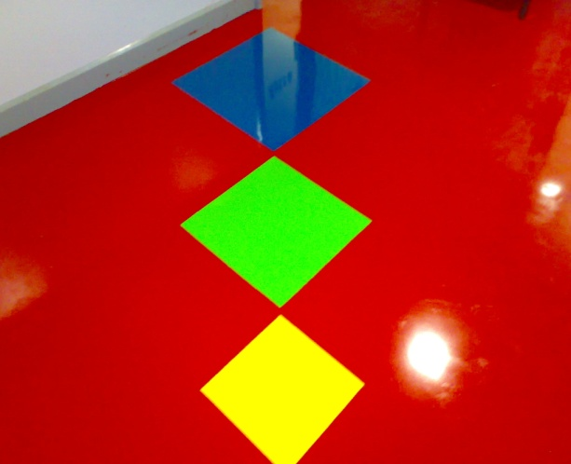

a) Introduction
AKSHAYA is associated with ASTRA & CIPY POLYURATHANE which supplies to government, commercial, industrial and institutional customers with one of the most advanced epoxy and Polyurethane floor covering available in the world since 1996. We offer in-house training seminars as well as factory training for Applicators to provide technical assistance to ensure the successful installation of our Flooring system. Our products are extremely versatile, durable, environmentally safe, and user friendly. Akshaya is a cost-effective, long-lasting, easy to apply, easy to clean, and cosmetically appealing. It is a sensible alternative to quarry tile, ceramic tile and terrazzo.
We are currently in a rapid growth pattern, opening new domestic and international markets. We market our products directly through factory representatives and the application is done by factory trained employees of our company.
As an organized group of professionals, AKSHAYA strives to provide the highest level of product quality, technical support and customer service to our partners and clients. Attention to detail and quality assurance starts in the manufacturing process and continues throughout the entire operation and is transferred to the customers site where our trained applicators will insure that the installation meets our high quality standards. Each member of our company contributes their unique perspective.
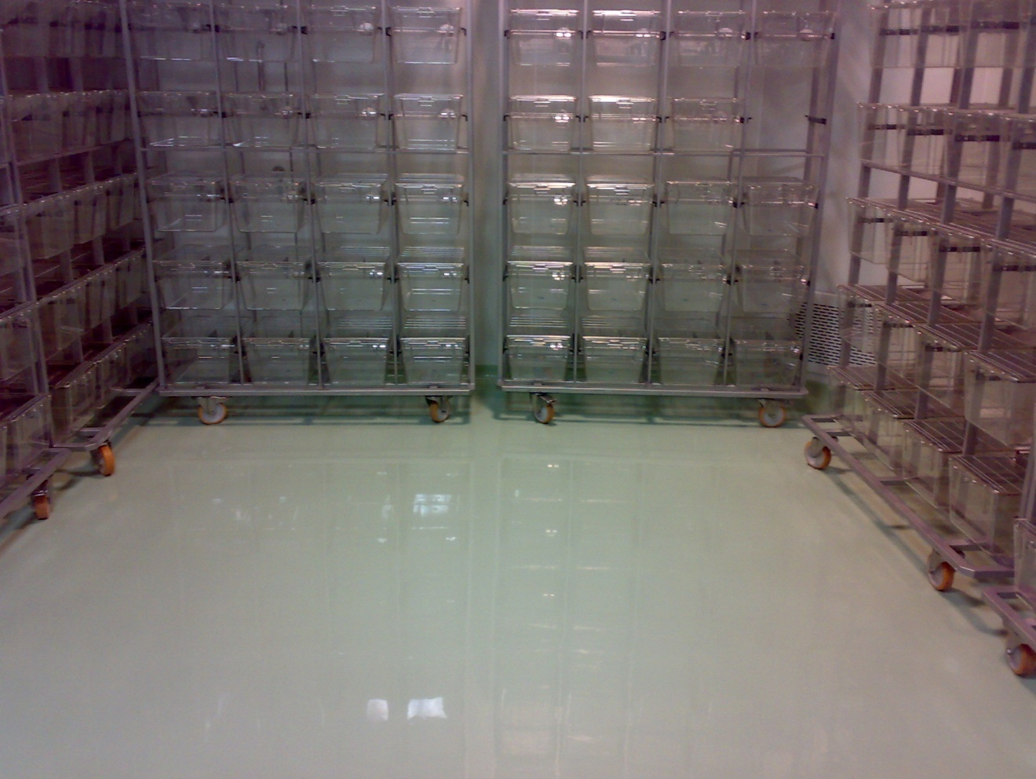
ADVINUS THERAPEUTICS

AKSHAYA One-Step Seamless Flooring System covering is a 100% solid epoxy, which comes in pre-measured kit form. It is mixed, poured out and trowel down into a completely monolithic slab, giving you a lightweight, flexible long lasting/durable, easy to clean, non-porous, chemical and fire resistant seamless flooring system.
With no volatile organic compounds, our product poured epoxy / PU flooring is environmentally safe, user friendly and easy to apply. There is no objectionable odour during application: Foodstuffs in restaurants or manufacturing plants do not need to be removed, and respirators do not need to be worn by installers. Special ventilation requirements are not necessary. People can continue to work in adjacent areas without any inconvenience.
Our Seamless Flooring System has a natural texture finish when troweled. It may be installed in smooth or non-slip textures. A wide variety of colours are available. You can design your floor with any combination of colours using metal strip dividers to separate colors and actually create patterns. A sealer coat can be applied to provide a smoother surface that is easier to maintain. The rapid curing qualities make seamless epoxy flooring suitable for repair of damaged floors overnight. A manufacturing plant or restaurant floor can be repaired and ready for use again for next day service. Depressions can be filled in and floors pitched or levelled.
Cost savings are significant. With AKSHAYA One-Step seamless poured epoxy flooring, you can in most cases eliminate costly rip-out of the existing floor. It can be applied over it your existing linoleum, ceramic or quarry tile, metal, wood, concrete, VCT, VAT, sheet vinyl and can also be installed on vertical surfaces such as steps, walls, or fountains. Simply sweep the existing floor, clean to remove surface dirt and grease, then mix, pour out and trowel down the floor system - in a one-step application. Our seamless Epoxy flooring does not require a primer or bond coat due to its resin rich formulation. Ready to use within 24 hours, it will outlast other types of epoxy flooring systems.
Industrial Epoxy Flooring
AKSHAYA is Cost Effective:
• | Quick one-step installation - saves time and money.
• | Installs in less than one day vs. other types of flooring which take 3-4 days.
• | Tough wearing surface requires no periodic resealing.
• | Can be applied over existing flooring such as wood, metal, concrete, quarry and ceramic tile and on any kind of solid surface thus eliminating the cost of removing the old floor.
• | Less expensive over a lifetime compared to most flooring surfaces.
• | Lightweight, troweled
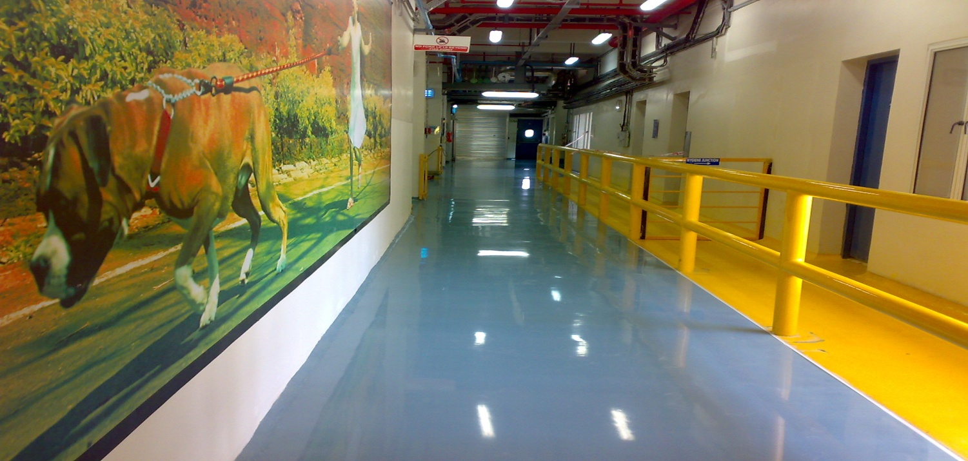
MARS INTERNATIONAL

Easy to Apply:
• | Versatile, easy handling, and packaged in kits.
• | Resin rich formula is easy to trowel and will not stick to tools.
• | Aggregate is sized to gauge application thickness.
• | Can be applied vertically for base cove applications and even stairs.
• | Substrates may be filled, levelled, or pitched.

• | Non-toxic with no objectionable odours and does not require forced air ventilation or the wearing of respirators.
• | No risk of contamination of foodstuffs.
• | Inherent anti-microbial properties.
• | No volatile organic compounds (VOCs).
• | Bacteria will not penetrate, unlike concrete or grouted tile. 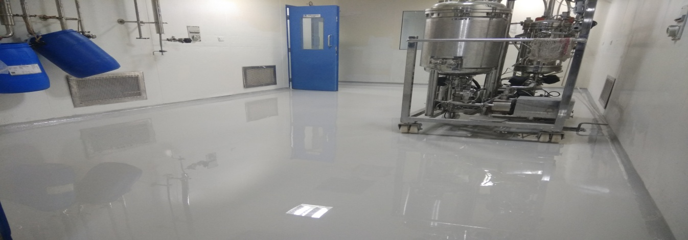  Bi.e LIMITED
AKSHAYA has Excellent Physical Properties:
• | Ideal for Commercial, Institutional and Industrial applications in areas requiring durability, easy maintenance, a high degree of sanitation, attractive appearance, and high resistance to chemicals or heat.
• | Excellent low temperature properties in cold temperature environments.
• | Unlimited life expectancy with proper maintenance.
• | Tremendous bonding strength to a variety of substrates.
• | Seamless. No joints or seams for water penetration.
• | Non-porous and non-absorbent -- thus it's sanitary, and easily cleaned with just a mop.
• | Corrosive/acid/oil/abrasion/impact resistant.
• | Non-conductive.
• | Non-toxic (and no smell during mixing and lay-down -- no VOCs).
• | Flexible (flexes with movement to include onboard ships).
• | Shock resistant.
• | Heat resistant.
• | Slip resistant - even when wet.
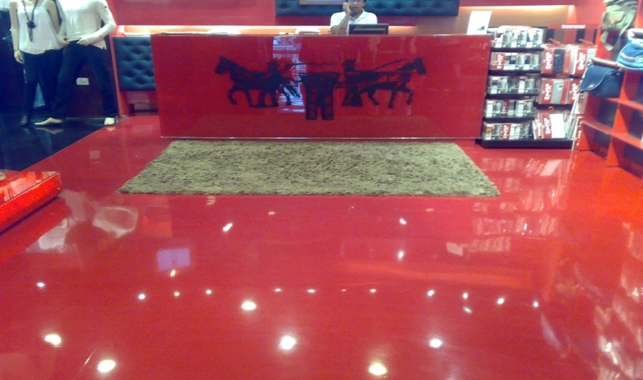
LEVI'S STORES
AKSHAYA is Attractive:
• | Terrazzo/marble appearance is available in a number of styles and colors, and patterns. Picture frame bordering effects and other designs can be produced. It is an outstanding floor system for any area where a highly decorative floor is desired.
Assuring the best support and service at all times.
Thanking you,
Yours truly,
For Akshaya Enterprises

S.Chandrakantha Reddy.
E-mail:akshaya.ckr@gmail.com
Hand Phone:+919866076372.

